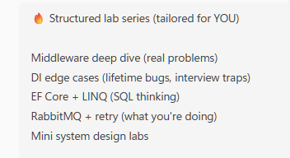
🚀 LAB SERIES (ASP.NET Core Focus)
We’ll go in this order:
- Middleware (deep understanding)
- Dependency Injection (real bugs + lifetimes)
- EF Core + LINQ (SQL thinking)
- Mini API (combine everything)
- Mini system design (within .NET)

🧪 LAB 1 — Middleware (Request Monitoring)
🎯 Problem
Your team wants visibility into API performance.
Build a custom middleware that monitors all incoming requests.

✅ Requirements
1. Log request details
- HTTP Method
- Path
- Timestamp

2. Measure execution time
- Calculate total time taken for each request

3. Add response header
Every response should contain:
X-Execution-Time: <time in ms>

4. Detect slow requests
If request takes more than:
500 ms
Log it as:
SLOW REQUEST: <method> <path> took <time>

5. Skip certain routes
Middleware should NOT run for:
/health
/swagger

6. Exception safety
Even if controller throws error:
- Middleware should still log execution time

🧪 LAB 2 — Dependency Injection (Lifetime Bugs)
🎯 Problem
A discount service behaves inconsistently across users.

✅ Requirements
1. Create a service
IDiscountService
With method:
GetDiscount()

2. Implementation
- Maintain internal state (counter)
- Each call increases discount value

3. Inject into controller
Expose endpoint:
GET /discount

4. Test behavior
Call endpoint multiple times and observe:
- Whether values are shared
- Whether values reset per request

5. Experiment with lifetimes
Test with:
- Singleton
- Scoped
- Transient

6. Broken scenario (important)
Create:
- A Singleton service depending on a Scoped service
Observe:
- Runtime behavior or errors

🧪 LAB 3 — EF Core + LINQ (SQL Thinking)
🎯 Problem
You are building reporting queries on order system.

✅ Data Model
You must design:
- Customer
- Order
- OrderItem
With proper relationships.

✅ Requirements
1. Customers with multiple orders
Return customers with more than N orders.

2. Top selling product
Find product with highest total quantity sold.

3. Revenue per customer
Calculate total revenue for each customer.

4. Orders grouped by period
Group orders by:
- Month
- Year

5. Avoid N+1 problem
Demonstrate:
- A scenario that causes multiple DB queries
- Fix it using proper loading strategy

6. Think in SQL
For each query:
- Understand what SQL it generates

🧪 LAB 4 — Build Order API (Architecture)
🎯 Problem
Build a structured backend for managing orders.

✅ Requirements
APIs
POST /orders
GET /orders/{id}
GET /orders?customerId=1

1. Layered design
Use:
Controller → Service → DbContext

2. DTO usage
Do NOT expose EF entities directly.

3. Data handling
- Create orders with items
- Fetch single order with items
- Fetch orders by customer

4. Query optimization
- Use projection (Select)
- Avoid unnecessary data loading

5. Validate inputs
Handle:
- Invalid customer
- Empty order

🧪 LAB 5 — Global Exception Handling
🎯 Problem
Your API returns inconsistent errors.

✅ Requirements
1. Create global exception middleware
Catch all unhandled exceptions.

2. Return consistent JSON response
Format:
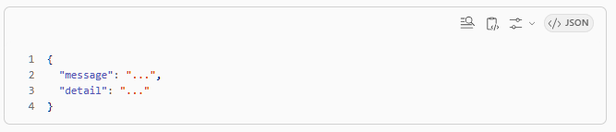
3. Handle specific exceptions
Example:
- KeyNotFoundException → 404
- Generic exceptions → 500

4. Logging
Log:
- Error message
- Path

5. Middleware order
Ensure it executes before other components.

🧪 LAB 6 — Authentication (JWT + Identity)
🎯 Problem
Secure your API so only authenticated users can access it.

✅ Requirements
1. User management
Implement:
POST /auth/register
POST /auth/login

2. Identity integration
Use ASP.NET Identity for:
- User storage
- Password validation

3. JWT generation
On login:
- Generate token with claims
- Set expiration

4. Protect APIs
- Secure order endpoints using [Authorize]

5. Token validation
Ensure:
- Invalid token → rejected
- Expired token → rejected

6. Optional (bonus)
- Add roles
- Protect endpoints using roles

🧪 FINAL LAB — Performance + Caching
🎯 Problem
Your API is slow due to repeated DB queries.

✅ Requirements
1. Add caching
Use in-memory cache to store responses.

2. Cache read APIs
- Cache:
- GET /orders/{id}
- GET /orders?customerId=1

3. Cache expiry
- Set expiration time

4. Cache invalidation
When data changes:
- Remove relevant cache entries

5. Measure improvement
- Log:
  - Cache hit
  - Cache miss

6. Design thinking
Explain:
- When caching is useful
- When it is harmful

🔥 FINAL RESULT (what you achieve)
If you complete all:
You now know:
✅ Middleware pipeline
✅ DI lifetimes (deep)
✅ EF + SQL thinking
✅ API architecture
✅ Error handling
✅ Authentication
✅ Performance optimization

💬 How to use this
Best way:
- Pick one lab
- Don’t look old code
- Implement from scratch
- Struggle → then refine

Answers

🔥 LAB 1 — Middleware Deep Dive
🎯 Scenario (Realistic)
Your team wants to:
Monitor every request performance and log slow APIs

✅ Your Task
Create a custom middleware that:
1. Logs request details
- HTTP Method
- Path
- Timestamp

2. Measure execution time
- Use a timer
- Calculate total time taken for request

3. Add response header
Add:
X-Execution-Time: <milliseconds>

4. Log ONLY slow requests
If request takes:
> 500 ms
Log:
"SLOW REQUEST: GET /api/orders took 723 ms"

5. Skip specific endpoints
Do NOT run middleware for:
/health
/swagger

✅ Constraints (important)
- ❌ Do NOT use built-in logging middleware
- ✅ Use RequestDelegate
- ✅ Use HttpContext
- ✅ Must be async-safe

✅ Expected Flow
Request → Middleware → Controller → Middleware (after response)

🧠 What you are learning
- Pipeline execution
- Before vs After response
- Short-circuiting
- Real-world observability pattern

🔥 Edge case (must handle)
👉 What if exception happens in controller?
- Should middleware still log?
- How will you capture time?

💡 Hints (only if stuck)
Hint 1: Timer
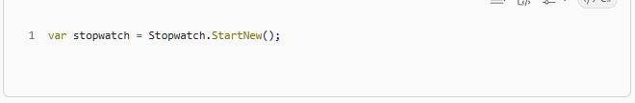
Hint 2: Call next middleware
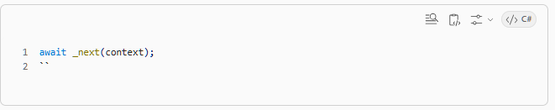
Hint 3: Add header
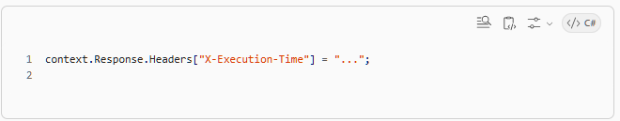
Hint 4: Skip paths
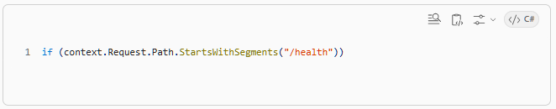
✅ Your Deliverable
You should end up with:
- Custom middleware class
- Registered in pipeline:
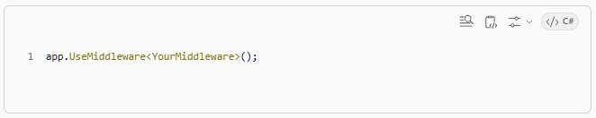
✅ Once you finish
Tell me:
👉 “done”
Then I will:
- Review your approach (like a senior dev)
- Point mistakes (if any)
- Give next lab (DI — where things get interesting 😈)

⚠️ One rule
Don’t rush.
Take time, implement, run, break it.

If you get stuck, ask like:
“I wrote this but not working”
I’ll debug with you step-by-step ✅

🔥 LAB 1 — FULL STEP-BY-STEP (Middleware)

✅ Step 1: Create Project
👉 Open Visual Studio
- Click Create a new project
- Select:
ASP.NET Core Web API
- Click Next

👉 Configure:
- Project Name: MiddlewareLab
- Location: any folder
- Solution: keep default
Click Next

👉 Framework config:
- ✅ .NET 8 (or whatever you have)
- ✅ Enable OpenAPI (Swagger) → keep checked
Click Create

✔️ Now project is ready

✅ Step 2: Run once (sanity check)
Press:
Ctrl + F5
👉 Swagger should open
If it works → good ✅

✅ Step 3: Create Middleware Class

👉 Right click project → Add → New Folder
Name:
Middleware

👉 Inside that folder
Right click → Add → Class
Name:
RequestTimingMiddleware.cs

👉 Replace FULL code with this
(yes, copy paste — we’ll understand after)
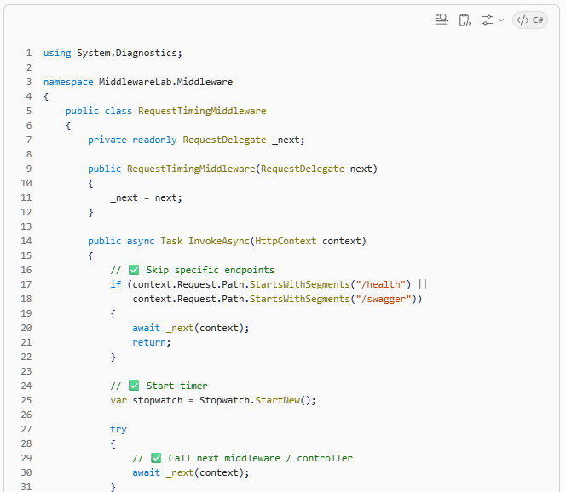
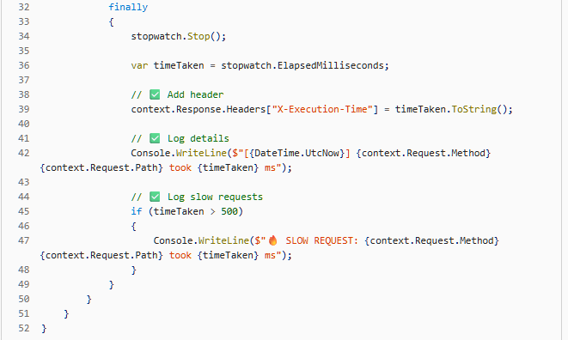
✅ Step 4: Register Middleware

👉 Open Program.cs
You’ll see something like:
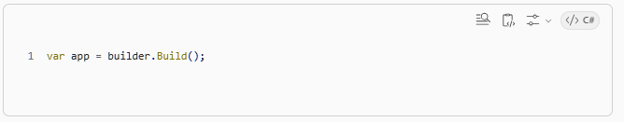
✅ ADD this line AFTER app creation:
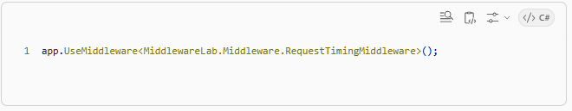
🔥 Final should look like:
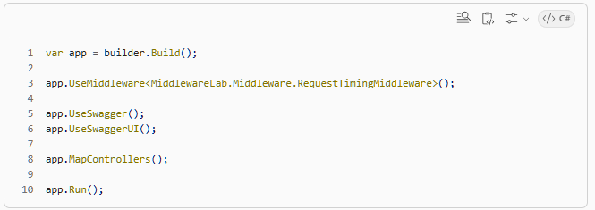
⚠️ Order matters:
- Middleware should be before MapControllers

✅ Step 5: Create Test Endpoint

👉 Inside Controllers folder
Open WeatherForecastController.cs

✅ Add a slow endpoint:
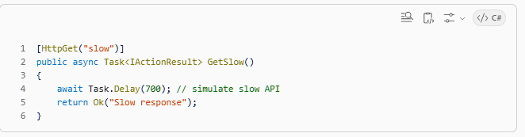
✅ Step 6: Run and Test

👉 Run project:
Ctrl + F5

👉 Go to Swagger
Call:
GET /weatherforecast/slow

✅ What you should see
✅ In Console
GET /weatherforecast/slow took 702 ms
🔥 SLOW REQUEST: GET /weatherforecast/slow took 702 ms

✅ In Response Headers
X-Execution-Time: 702

✅ Step 7: Test skip logic
Call:
/swagger
👉 No log should appear ✅

🧠 Now understanding (VERY IMPORTANT)

🔹 What is happening?
Request → Your Middleware → Controller → Your Middleware (back)

🔹 This line:
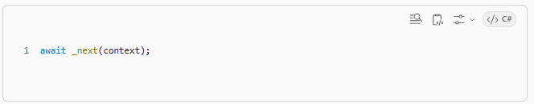
👉 Means:
“Pass request to next layer”

🔹 try/finally
👉 Even if controller crashes:
- Middleware still logs
- Time still calculated ✅

🔥 This is REAL production pattern
Companies use this for:
- Logging
- Performance monitoring
- Observability

✅ What you just learned
- Middleware pipeline
- Request/response flow
- Custom headers
- Filtering endpoints
- Exception-safe logging

🔥 LAB 2 — Dependency Injection (Lifetimes & Hidden Bugs)
🎯 Scenario (Real company problem)
Your team built a service:
“Calculate order discount”
Everything works fine…
but suddenly in production:
❌ Wrong discounts applied
❌ Random behavior across requests
👉 Root cause → DI lifetime issue

✅ Step 1: Create Interface
👉 In your project:
Right click → Add → New Folder → Services

Add file: IDiscountService.cs
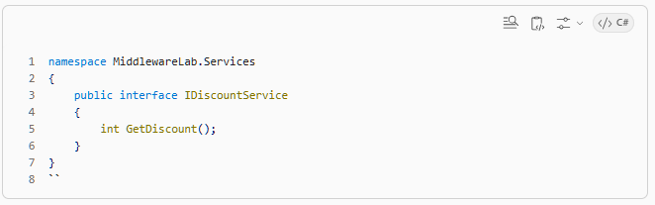
✅ Step 2: Create Implementation

Add file: DiscountService.cs
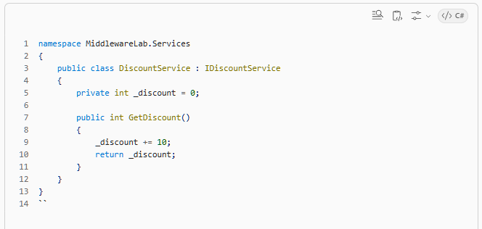
⚠️ IMPORTANT:
👉 This _discount is stateful
That means:
Call 1 → 10
Call 2 → 20
Call 3 → 30

✅ Step 3: Register in DI

👉 Open Program.cs
Add:
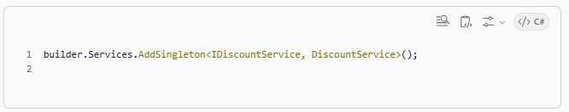
✅ Step 4: Use in Controller

👉 Open WeatherForecastController.cs
Modify:
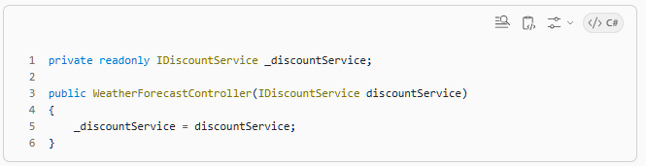
Add endpoint:
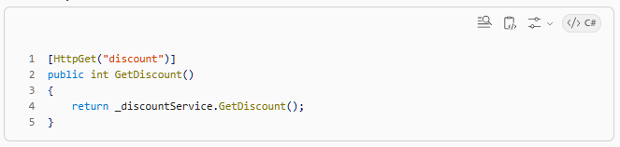
✅ Step 5: Run and Test

👉 Call this endpoint multiple times:
GET /weatherforecast/discount

✅ Observe output
First call:
10
Second call:
20
Third call:
30

🔥 PROBLEM (THIS IS THE BUG)
👉 This is WRONG behavior
Each request should be independent.
But now:
One user's request affects another user's response 😱

🧠 Why this happened?
Because:
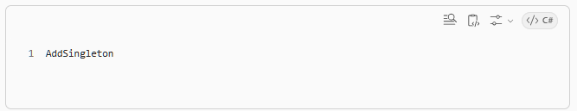
Means:
✅ ONE instance for entire application
So _discount is shared globally

✅ Fix it (do this now)
Replace:
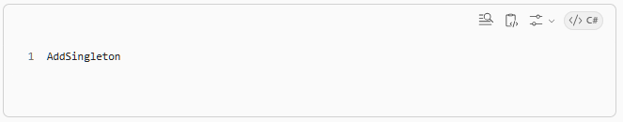
With:
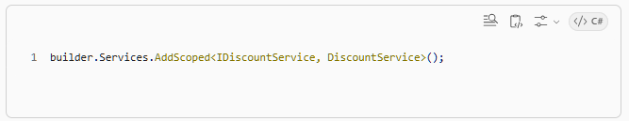
✅ Test again
Now call:
GET /weatherforecast/discount

✅ Output now:
Always:
10

✅ Because each request gets a fresh instance

🧠 Core concept (VERY IMPORTANT)
Lifetime | Behavior
Singleton | One instance for entire app
Scoped ✅ | One instance per request
Transient | New instance every time

🔥 REAL INTERVIEW QUESTION (you MUST know)
❓ What happens if:
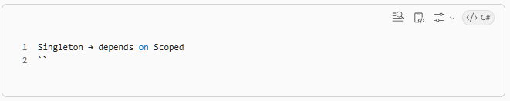
👉 Example:
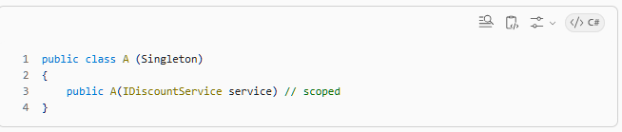
❌ This causes:
Runtime error OR wrong behavior
Because:
- Singleton lives forever
- Scoped lives per request
👉 Lifetime mismatch 🔥

✅ Task (IMPORTANT — don’t skip)
Try this:

🔴 Break the app intentionally
- Keep:
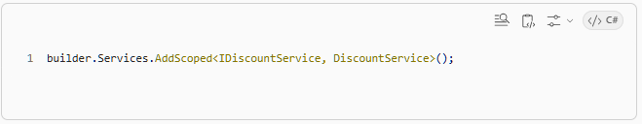
Create new service:
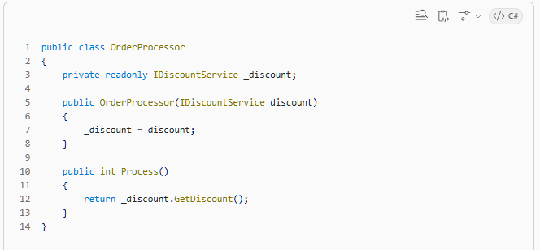
Register:
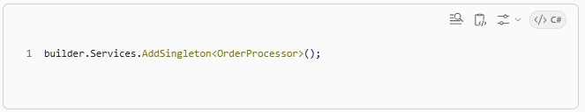
👉 Run app
❓ What happens?

🎯 Expected learning
- Lifetime mismatch error
- Why DI rules exist
- How bugs happen in production

✅ Your Deliverable
You should:
- ✅ See wrong behavior with Singleton
- ✅ Fix using Scoped
- ✅ Try lifetime mismatch experiment

🔥 LAB 3 — EF Core + LINQ (SQL thinking)
🎯 Goal
You should not just write LINQ…
👉 You should see the SQL in your head

✅ Step 1: Setup DB (very simple)

👉 Add Models folder → create 3 classes

✅ Customer.cs
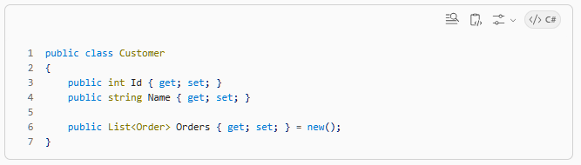
✅ Order.cs
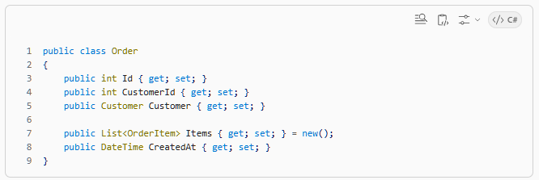
✅ OrderItem.cs
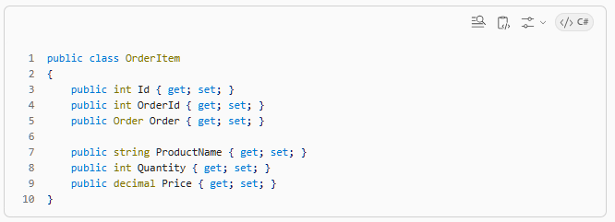
✅ Step 2: Create DbContext

👉 Add AppDbContext.cs
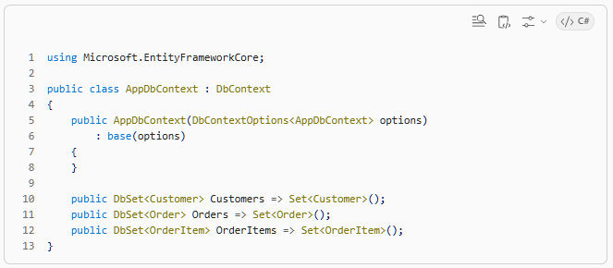
✅ Step 3: Register EF Core

👉 In Program.cs
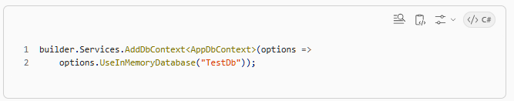
✅ In-memory is enough for learning

✅ Step 4: Seed Data (IMPORTANT)

👉 In Program.cs (before app.Run())
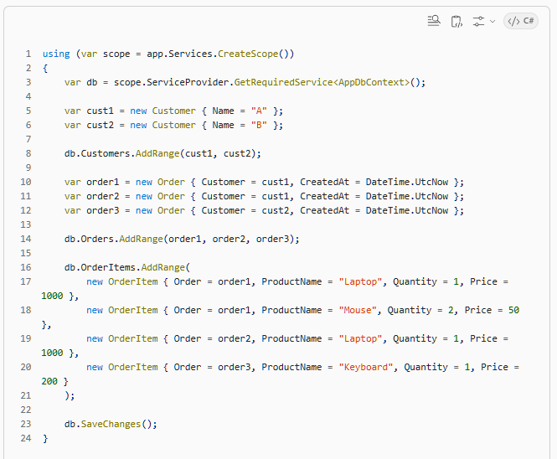
✅ Step 5: Create Controller

Create new controller:
OrdersController
Inject DbContext:
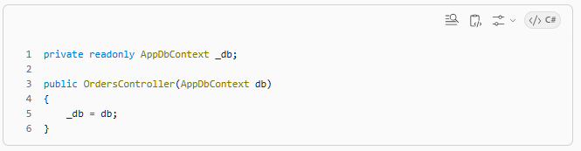
🔥 TASKS (REAL INTERVIEW LEVEL)

✅ Task 1: Customers with >1 orders

👉 Write LINQ
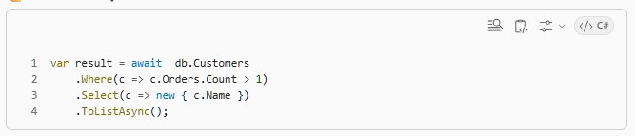
🧠 SQL in your head:
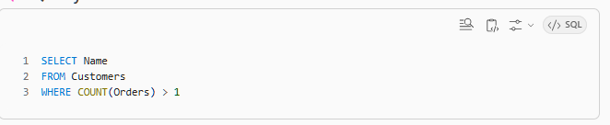
✅ Task 2: Top selling product

👉 LINQ
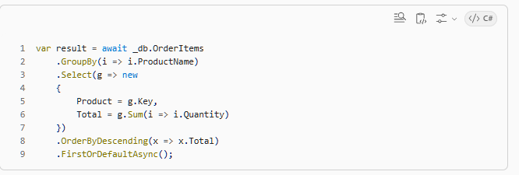
✅ Task 3: Total revenue per customer

👉 LINQ
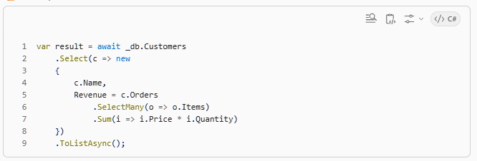
🧠 Key concept:
👉 SelectMany = JOIN flattening

✅ Task 4: Orders grouped by month
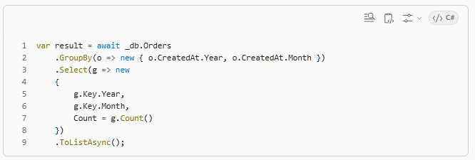
✅ Task 5 (🔥 important): Lazy loading vs Eager loading

❌ Problem:
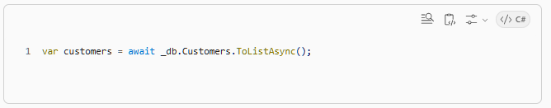
Then:
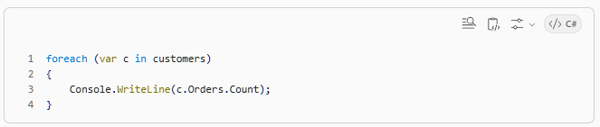
👉 This causes N+1 problem

✅ Fix:
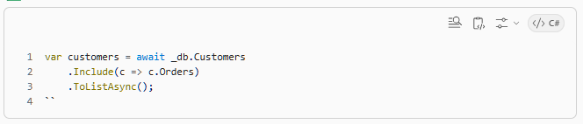
🧠 What you just learned
Concept | Why important
GroupBy | SQL aggregation
SelectMany | JOIN thinking ✅
Include | Avoid N+1
Projection | Efficient queries
Aggregates | SUM, COUNT

🔥 Interview-level understanding
You should now answer:
❓ Difference between Select vs SelectMany
❓ What causes N+1 issue
❓ How LINQ becomes SQL
✅ Your mini challenge (don’t skip)
👉 Write query for:
“Top 2 customers by revenue”

🔥 LAB 4 — Build Real API (Company-style task)
🎯 Scenario
You are building a basic Order Management API
Requirements from your team:
“We need clean APIs, proper layering, logging, and correct data handling”

✅ Step 1: What YOU will build
APIs:
POST /orders
GET /orders/{id}
GET /orders?customerId=1

✅ Step 2: Architecture (VERY IMPORTANT)
Don’t put everything in controller ❌
We’ll follow:
Controller → Service → DbContext

✅ Step 3: Create Service Layer

👉 In Services folder
Create:
IOrderService.cs
OrderService.cs

✅ IOrderService.cs
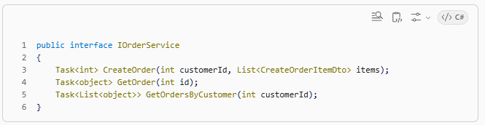
✅ Create DTO
CreateOrderItemDto.cs
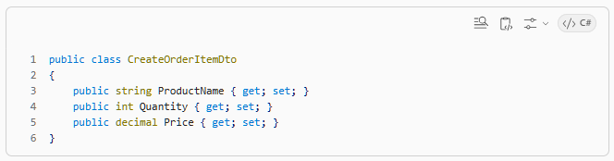
✅ OrderService.cs
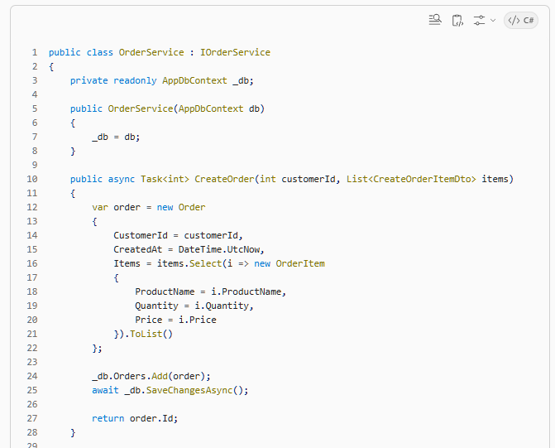
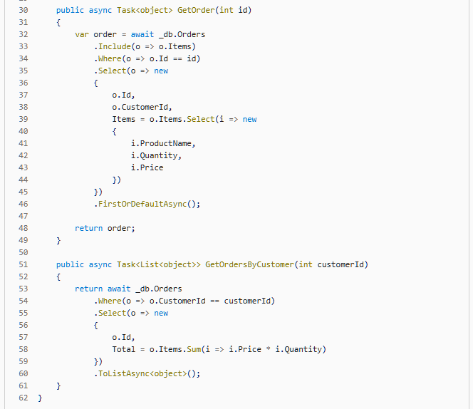
✅ Step 4: Register Service

👉 In Program.cs
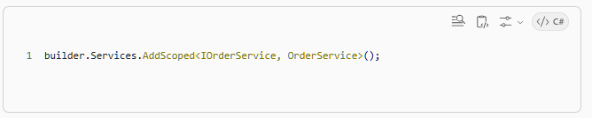
✅ Step 5: Create Controller

👉 Add new controller: OrdersController
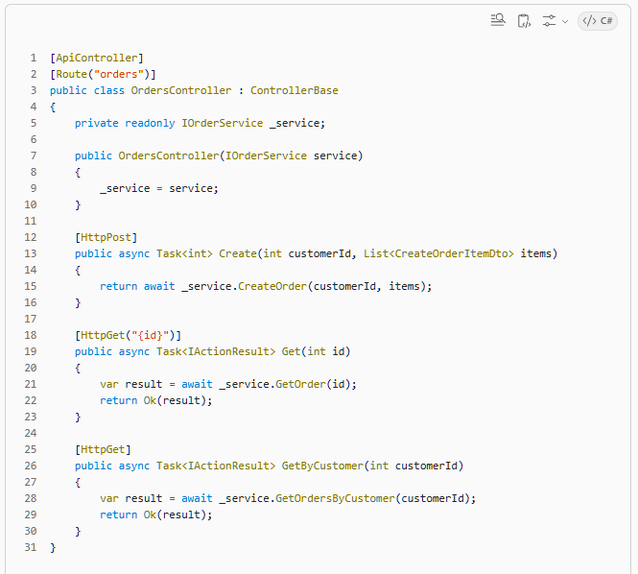
✅ Step 6: Run and Test

👉 Case 1: Create order
POST /orders?customerId=1
Body:
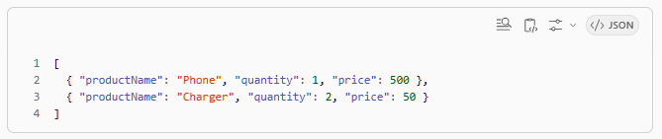
👉 Case 2: Get order
GET /orders/1

👉 Case 3: Get customer orders
GET /orders?customerId=1

🧠 What you just implemented
Concept | Used?
Middleware | ✅ (previous lab running)
DI | ✅
Service layer | ✅
EF Core | ✅
Projection | ✅
Include | ✅

🔥 Real-world improvements (important)

✅ 1. Validation (missing now)
- What if customerId invalid?
- What if empty items?

✅ 2. DTO separation
Right now returning object → bad practice
Use proper DTOs

✅ 3. Error handling middleware
You’ll add in next lab 👀

🔥 Mini Challenge (DO THIS)
Don’t skip.

👉 Add API:
GET /orders/top?count=2
👉 Returns top N orders by total amount

🧠 Hint:
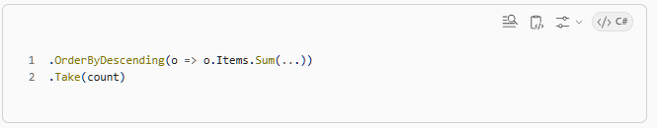
✅ What this lab gave you
Now you can:
✅ Build real API
✅ Use DI correctly
✅ Structure code like company
✅ Think in LINQ
✅ Avoid N+1

🔥 LAB 5 — Global Error Handling Middleware
🎯 Scenario
Right now your API:
- If exception happens → ❌ ugly stack trace
- No consistent error format
- No logging
👉 This is NOT production-ready

✅ Goal
Build a global exception middleware that:
- ✅ Catches all exceptions
- ✅ Logs errors
- ✅ Returns clean JSON response

✅ Step 1: Create Middleware

👉 In Middleware folder
Create:
ExceptionHandlingMiddleware.cs

✅ Paste this FULL code
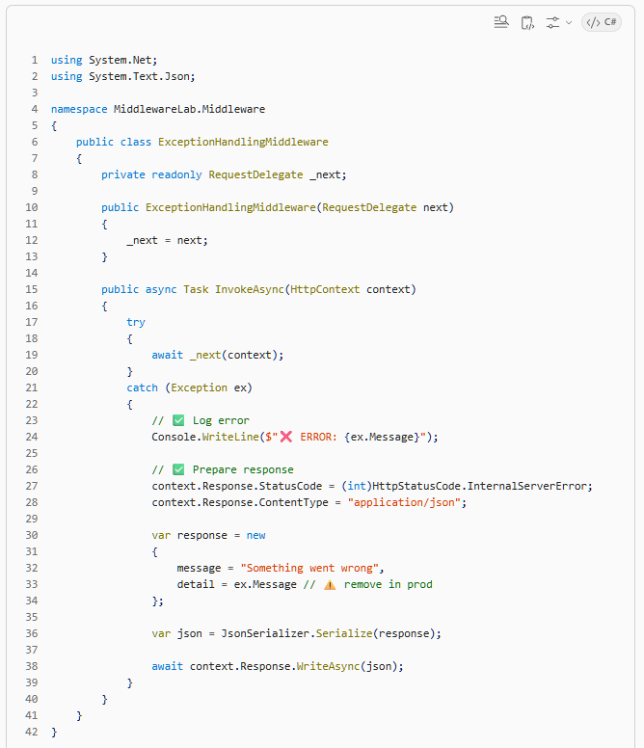
✅ Step 2: Register Middleware (IMPORTANT ORDER)

👉 Open Program.cs
Add this AT THE TOP of pipeline
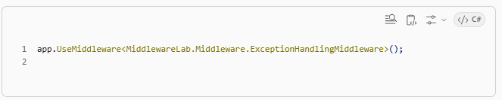
✅ Final order:
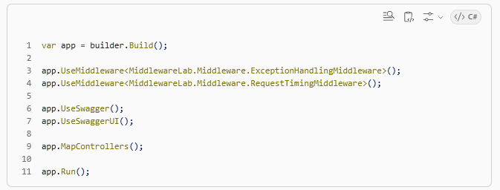

⚠️ VERY IMPORTANT:
👉 Exception middleware must be first
Because:
Request → ExceptionMiddleware → Everything else

✅ Step 3: Create a failing API

👉 In OrdersController
Add:
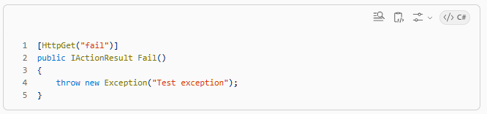
✅ Step 4: Test

👉 Call:
GET /orders/fail

✅ Before (without middleware)
You would see:
Huge stack trace 😵
HTML error page

✅ Now (with middleware)
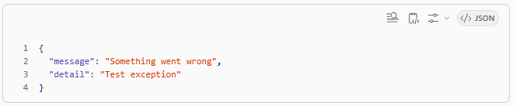
✅ Clean ✅ Consistent ✅ API-friendly

🧠 What you just learned

🔹 1. Global error handling
Instead of:
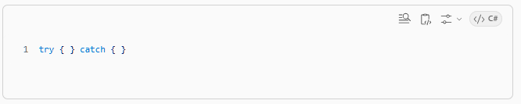
in every controller ❌
You centralized it ✅

🔹 2. Middleware order matters
Exception → Timing → Controller

🔹 3. Production vs dev behavior
In real production:
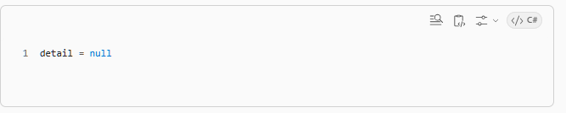
👉 Never expose internal errors

🔥 Next level improvements (real-world)

✅ 1. Add error codes
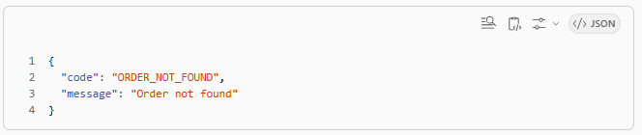
✅ 2. Handle specific exceptions
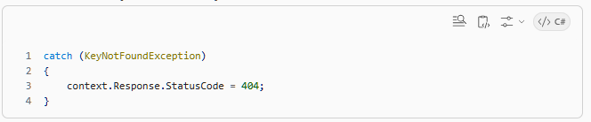
✅ 3. Use ILogger (instead of Console)
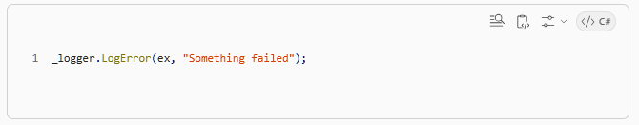
🔥 Mini Challenge (DO THIS)

👉 Modify middleware:
If exception is:
KeyNotFoundException
Return:
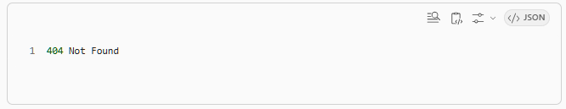
👉 Otherwise:
500 Internal Server Error

✅ What you’ve achieved now
You can now:
✅ Build APIs properly
✅ Structure code like real backend system
✅ Handle real production issues
✅ Understand middleware deeply
✅ Work with EF + DI together

🔥 FINAL LAB — Mini System Design (Inside .NET)
🎯 Scenario
Your API is working… but now problem comes:
❗ “GET /orders is slow”
❗ “Database is getting hit too much”
❗ “Same data is requested again and again”
👉 This is a real production problem

✅ Goal
You will implement:
🔥 Caching + Read Optimization

🧠 What you’ll learn
- Why APIs become slow
- How to reduce DB calls
- Read vs Write thinking
- Performance mindset ✅

✅ Step 1: Add Memory Cache

👉 In Program.cs
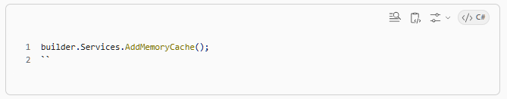
✅ Step 2: Modify OrderService

👉 Inject cache
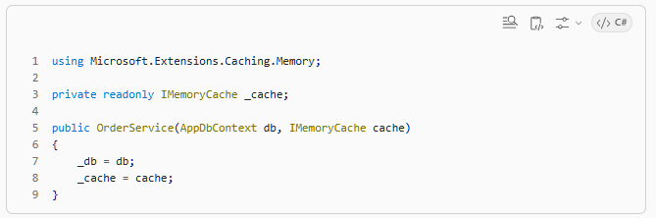
✅ Step 3: Cache GET /orders/{id}

Modify this method:
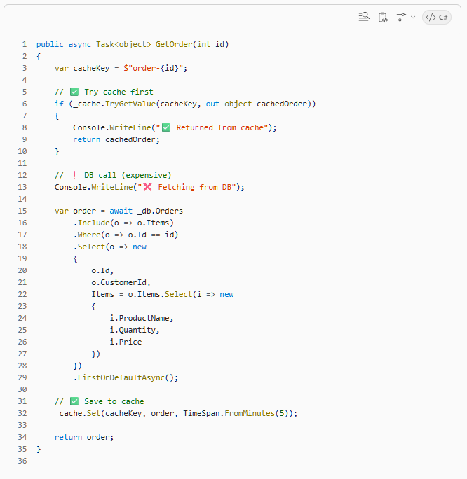
✅ Step 4: Test caching

👉 Call API:
GET /orders/1

✅ First call:
❌ Fetching from DB

✅ Second call:
✅ Returned from cache

👉 Boom — DB avoided 🔥

✅ Step 5: Handle Cache Invalidation (VERY IMPORTANT)

❗ Problem
If new order is created → cache becomes WRONG

✅ Fix: clear cache on write
Modify:
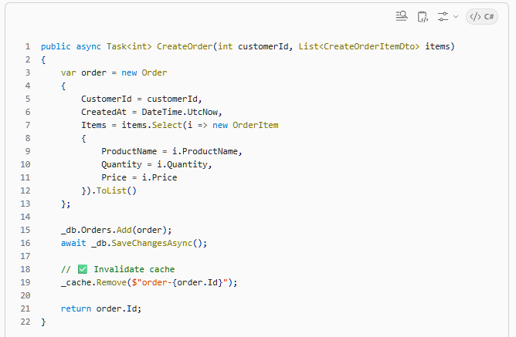
🧠 Key concept (VERY IMPORTANT)
Reads → Cache ✅
Writes → Invalidate cache ❗

✅ Step 6: Optimize list API

❗ Problem
GET /orders?customerId=1
👉 Might be called many times

✅ Add caching
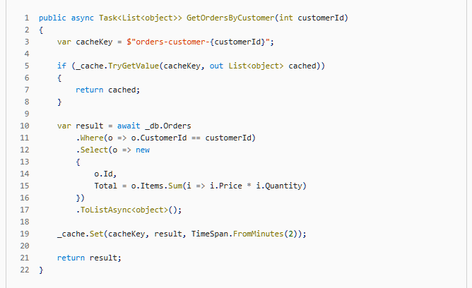
🔥 Final upgrade (think like senior dev)

✅ Problem: Memory cache is local
👉 On distributed systems:
- Multiple servers
- Cache mismatch

✅ Real-world solution:
- Redis ✅
- Distributed caching
- Cache expiration strategies

🧠 BIG SYSTEM DESIGN SHIFT

Before:
Every request → DB ❌

After:
Request → Cache ✅ → DB only if needed

✅ What you mastered in whole series

🔥 ASP.NET Core
- Middleware ✅
- Pipeline ✅
- Exception handling ✅

🔥 DI
- Lifetimes ✅
- Bugs ✅
- Real-world scenarios ✅

🔥 EF Core
- LINQ ✅
- SQL thinking ✅
- N+1 ✅

🔥 System thinking ✅
- Caching ✅
- Performance ✅
- Read/write separation ✅

✅ Final challenge (don’t skip)
👉 Answer this:
❓ When should you NOT use caching?

🚀 Real talk (important)
At this point…
👉 You’re no longer beginner
👉 You’re approaching product company level thinking

🔥 LAB 6 — JWT Authentication + ASP.NET Identity (REAL SETUP)
This is very important for interviews + real projects

🎯 Goal
You will build:
✅ User registration
✅ Login → generates JWT
✅ Protect APIs using [Authorize]
✅ Role-based authorization (optional bonus)

✅ Step 1: Install Packages
Run:
dotnet add package Microsoft.AspNetCore.Identity.EntityFrameworkCore
dotnet add package Microsoft.AspNetCore.Authentication.JwtBearer
✅ Step 2: Update DbContext

👉 Modify AppDbContext
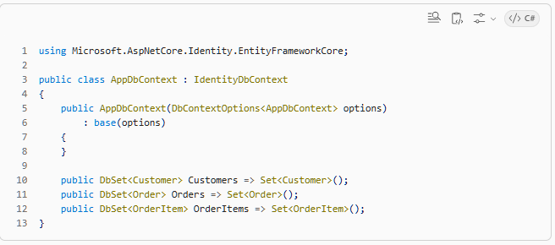
✅ This adds:
- Users table
- Roles table
- Claims, etc.

✅ Step 3: Configure Identity

👉 In Program.cs
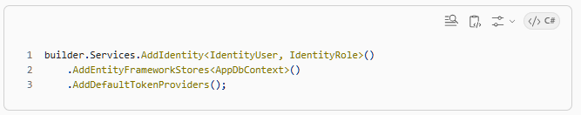
✅ Step 4: Add JWT Configuration

👉 In Program.cs
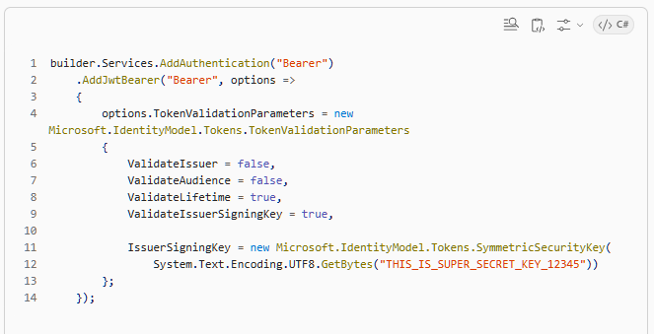
👉 Add this also:
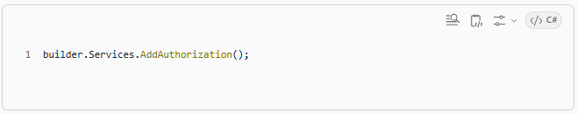
✅ Step 5: Enable Middleware

👉 In pipeline (Program.cs)
app.UseAuthentication();
app.UseAuthorization();
✅ Order:
app.UseMiddleware<ExceptionHandlingMiddleware>();
app.UseAuthentication();
app.UseAuthorization();
app.MapControllers();
✅ Step 6: Create Auth Controller

👉 Add AuthController.cs
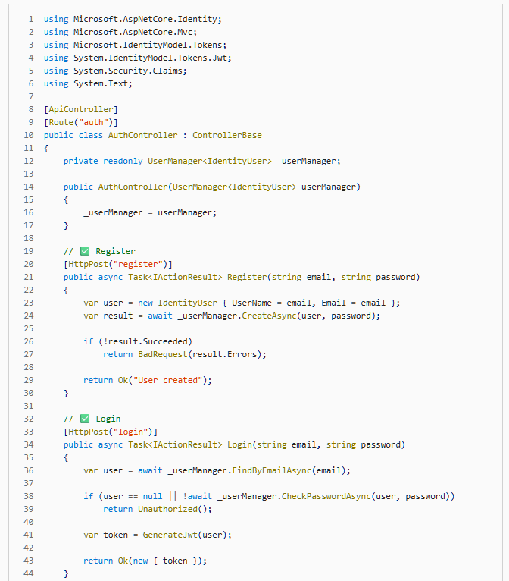
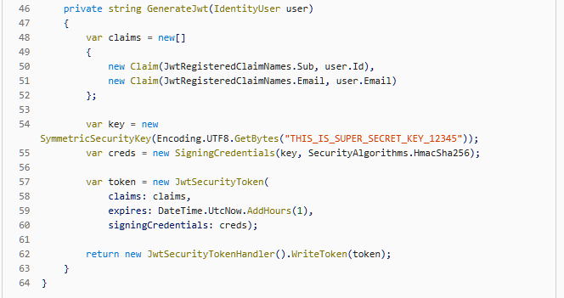

✅ Step 7: Protect Your API

👉 Open OrdersController
Add:
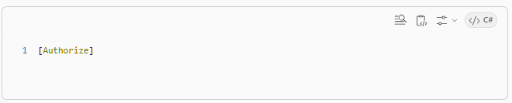
✅ Now:
GET /orders/1
👉 Requires JWT token

✅ Step 8: Test Flow (VERY IMPORTANT)

✅ 1. Register
POST /auth/register?email=test@test.com&password=Test@123

✅ 2. Login
POST /auth/login?email=test@test.com&password=Test@123
👉 You get:
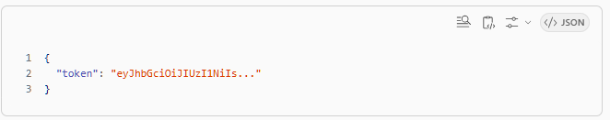
✅ 3. Call Protected API
👉 In Swagger:
- Click Authorize
- Paste:
Bearer <token>
Now call:
GET /orders/1
✅ Works

🧠 What you just learned

🔥 Authentication vs Authorization
Concept | Meaning
Authentication | Who are you? ✅
Authorization | What can you access? ✅

🔥 JWT flow
Login → Generate Token → Send with Request → Validate → Allow/Deny

🔥 Why JWT?
- Stateless ✅
- Works with microservices ✅
- No session needed ✅

🔥 BONUS (DO THIS)

✅ Role-based Authorization

Add role:
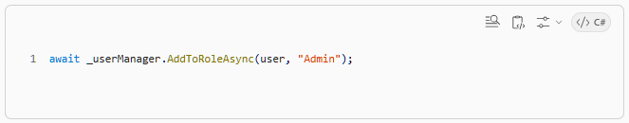
Protect endpoint:
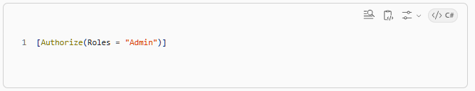
❗ Important Production Notes

❌ Don’t hardcode key
Use:
appsettings.json
Azure Key Vault

✅ Use HTTPS always

✅ Token expiry + refresh tokens (advanced)

🚀 What level you are at now
After this:
✅ Middleware
✅ DI
✅ EF Core
✅ Caching
✅ Authentication
👉 You are now very close to product company backend level

